M5. Assignment Resource

At the turn of the twentieth century, Europe seemed to enjoy a period of peace and
progress. Yet below the surface, several forces were at work that would lead Europe into the “Great War.” One of these forces was nationalism, and it had an explosive effect in the Balkans. But nationalism was only one of the many causes of World War I. Historians and eyewitnesses have described those causes and have tried to assess the responsibility for the war. Who and/or what caused World War I?

Source 1: Rise of Military Spending among Europe’s Leading Powers
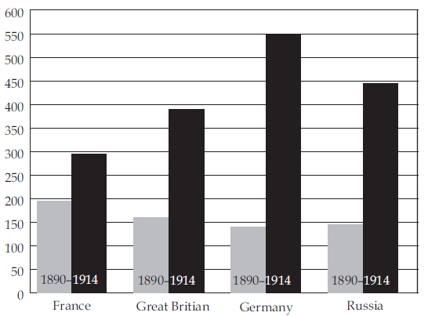
Source: James Killoran, Stuart Zimmer, Mark Jarrett, Mastering Global History, Jarrett Pub. Co., 1999.

Source 2: Map of Europe 1914
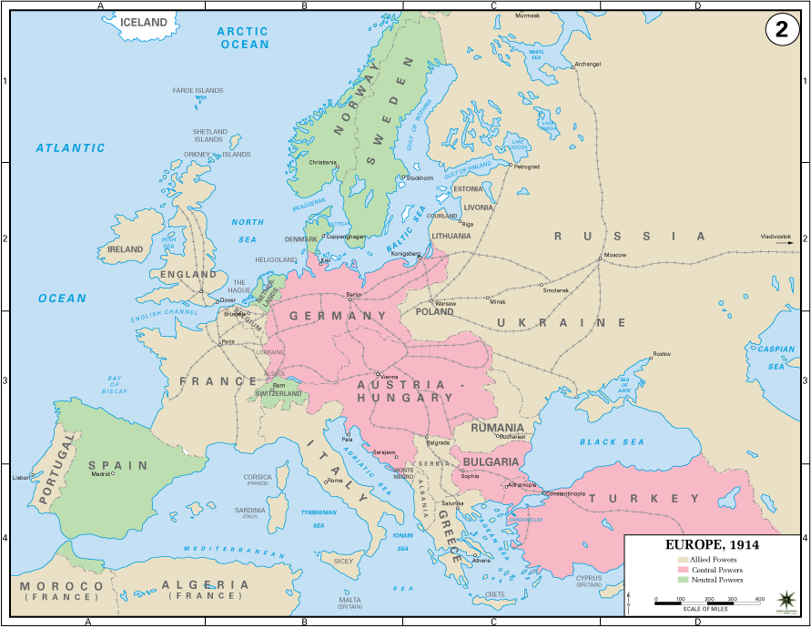
Immediately prior to the war's outbreak in 1914, Central Europe was dominated by two powerful states: Germany to the north and its weaker cousin, the Austro-Hungarian Empire, to the South. The two countries formed the core of the Central Powers, also known as the Quadruple Alliance because they were joined after war began by Bulgaria and the Ottoman Empire (modern Turkey). The other major pre-war alliance was the Triple Entente, a pact between Russia, Great Britain, and France (called the Allied Powers during the war).
Source: https://www.vox.com/a/world-war-i-maps

Source 3: Accusations against Serbia by Austria-Hungary
[T]he Royal Serbian Government has done nothing to repress these movements. It has permitted the criminal machinations of various societies and associations directed against the Monarchy, and has tolerated unrestrained language on the part of the press, the glorification of the perpetrators of outrages and the participation of officers and functionaries in subversive agitation…[The] Royal Government see themselves compelled to demand from the Royal Serbian Government a formal assurance that they condemn this dangerous propaganda against the Monarchy…To accept the collaboration in Serbia of representatives of the Austro-Hungarian Government for the suppression of the subversive movement . . .

Source: Austro-Hungarian Red Book No. 7, 1914.

